# **Name: Abdurrahman Qureshi**

# **Roll No: 242466**

Practical No: 8

Date Of Performance: 06/09/2025

Aim: To understand and demonstrate the use of Jenkins on AWS EC2 Instance

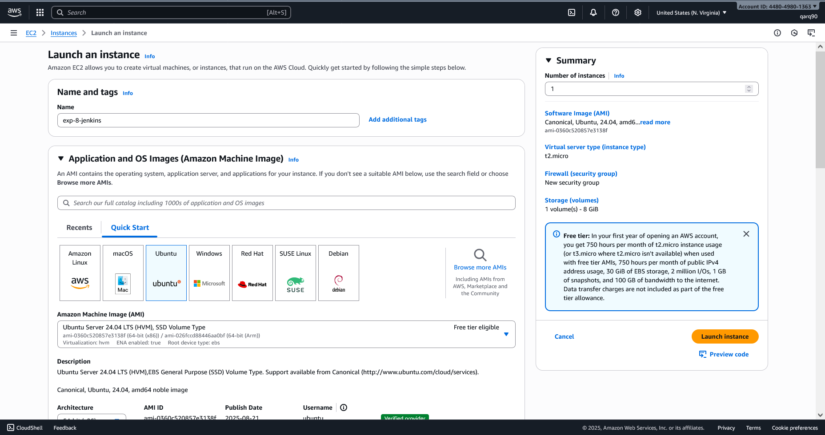

Creating an Instance

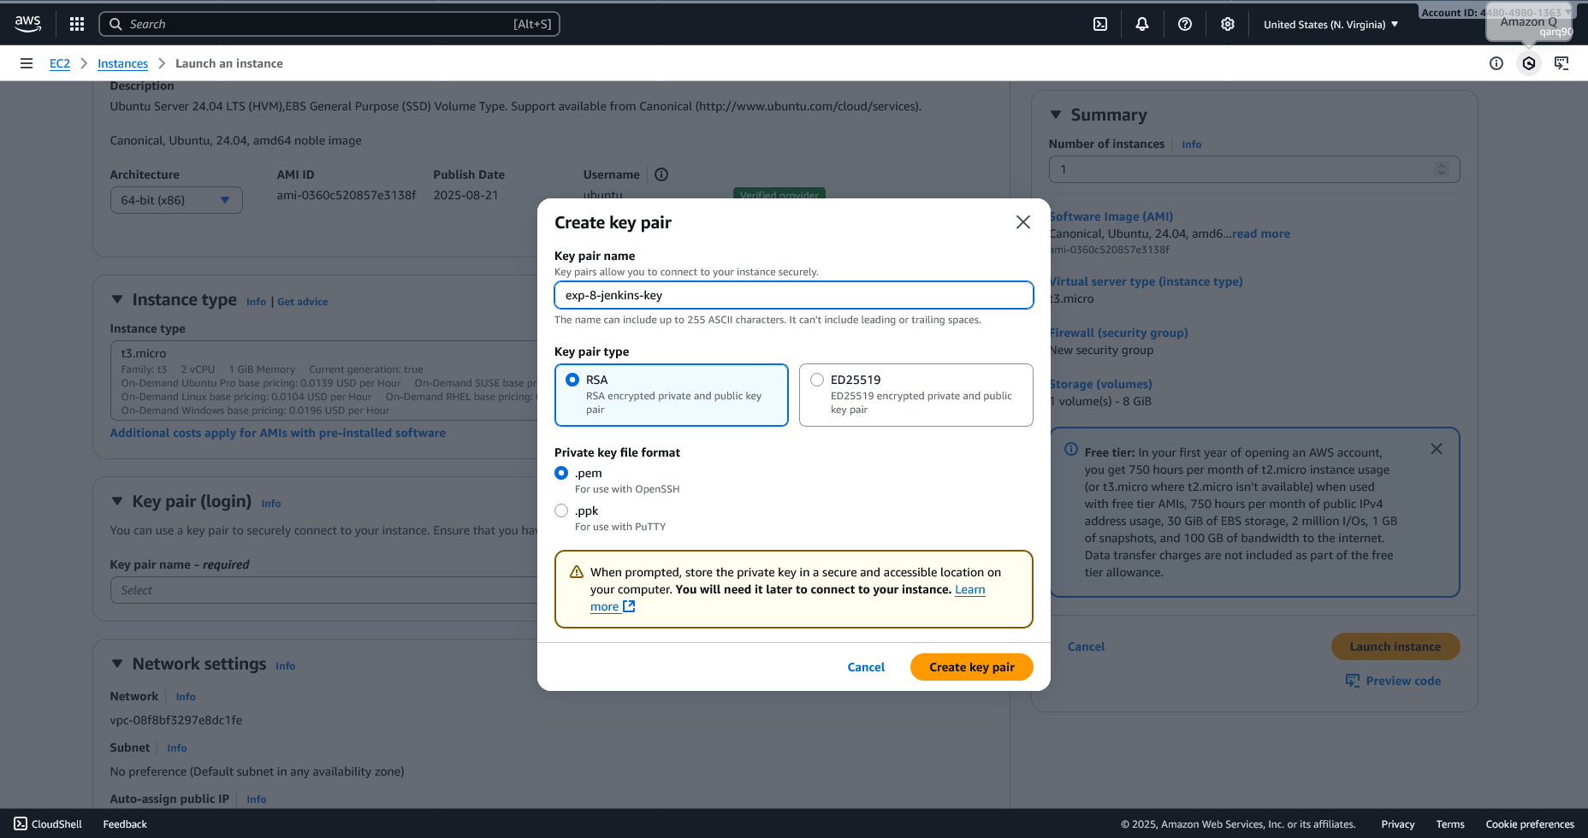

Creating the Key pair

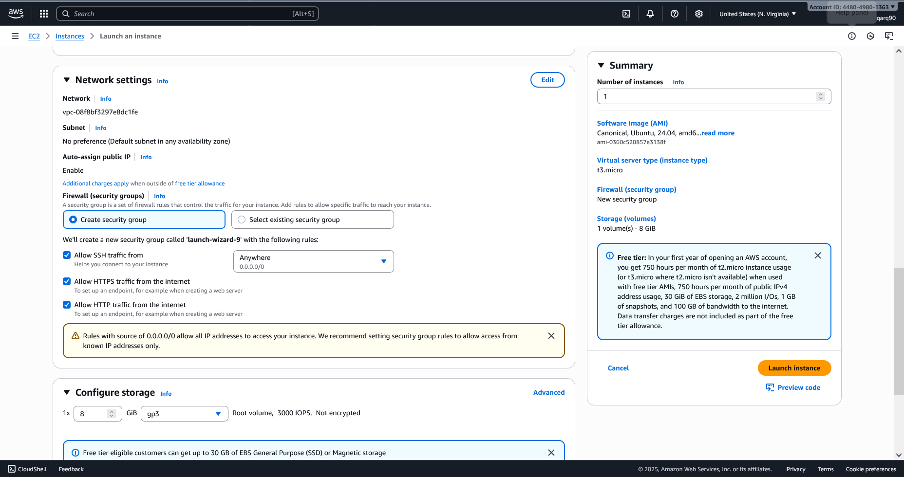

Configuring Network Settings

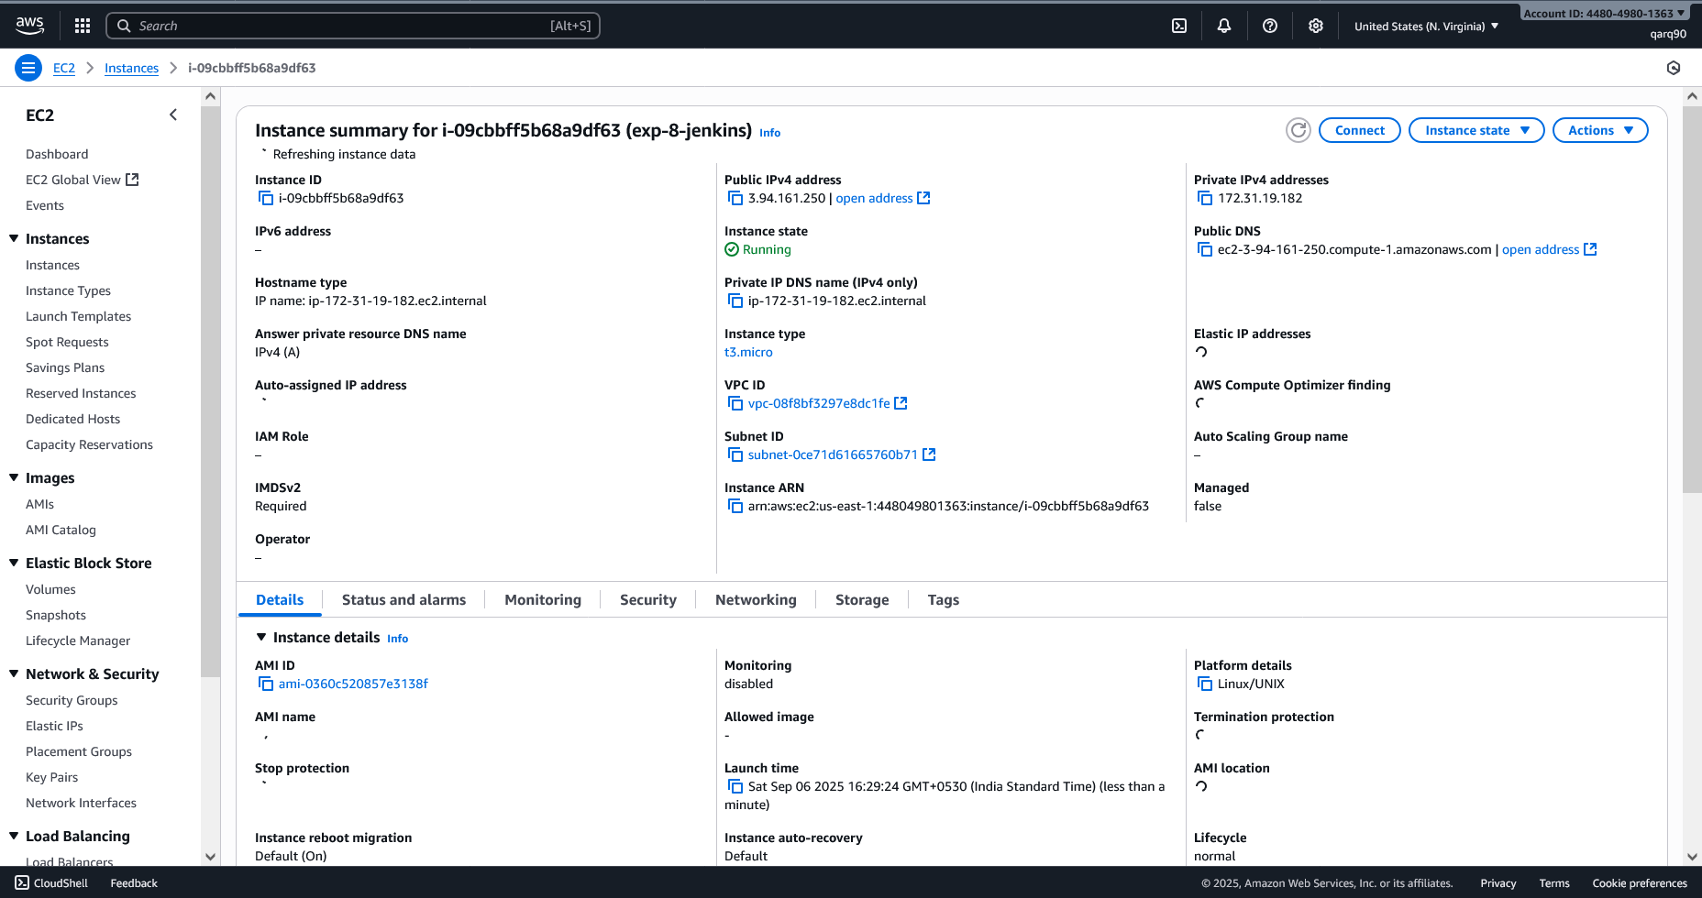

Instance Details

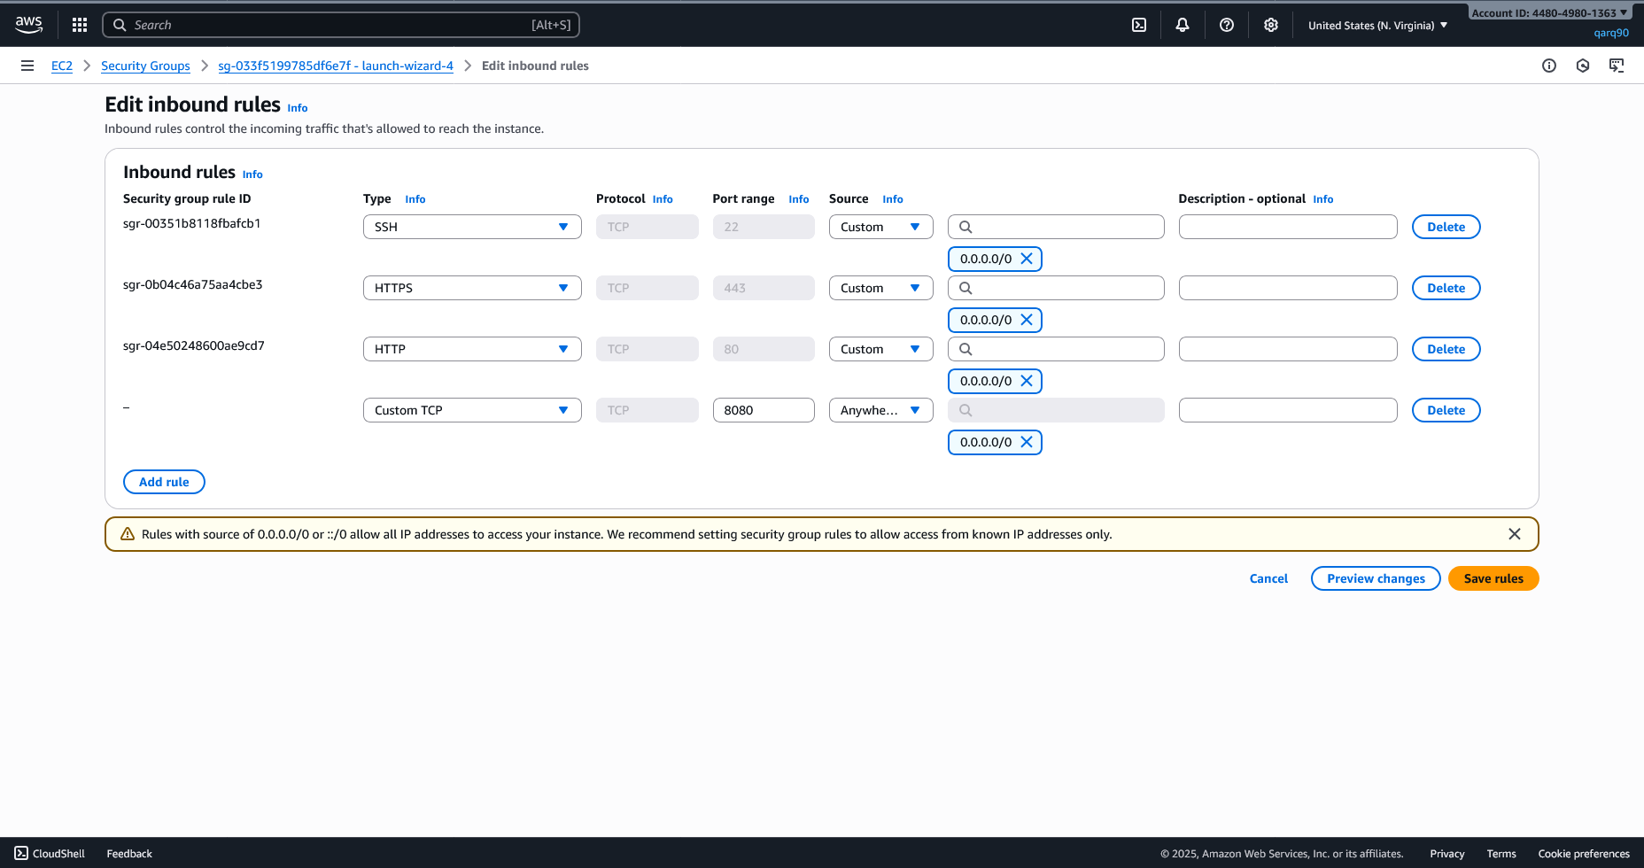

Editing Inbound Rules for Access

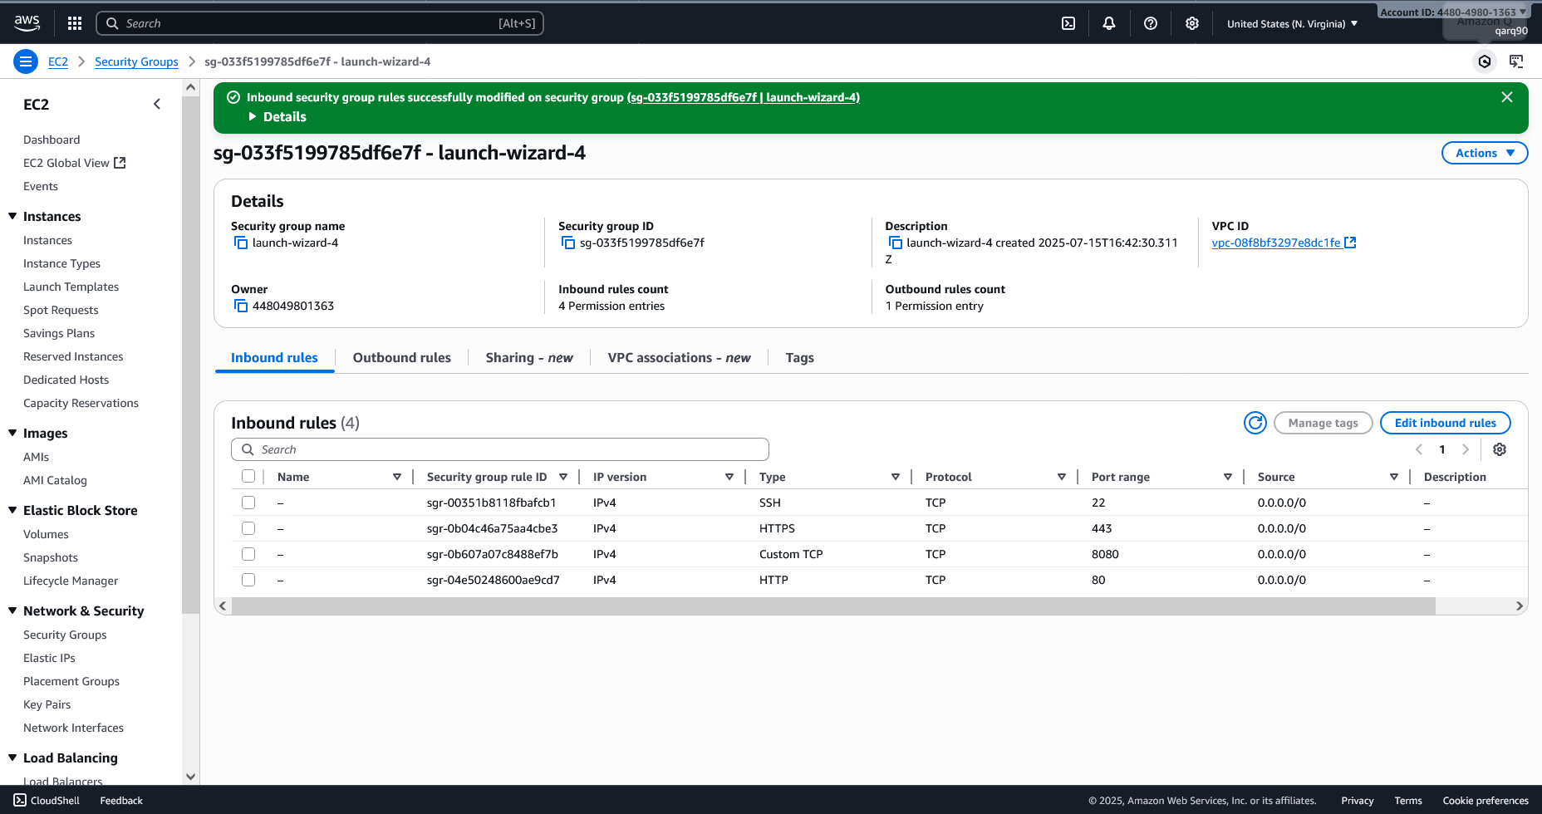

Inbound rules Updated Successfully

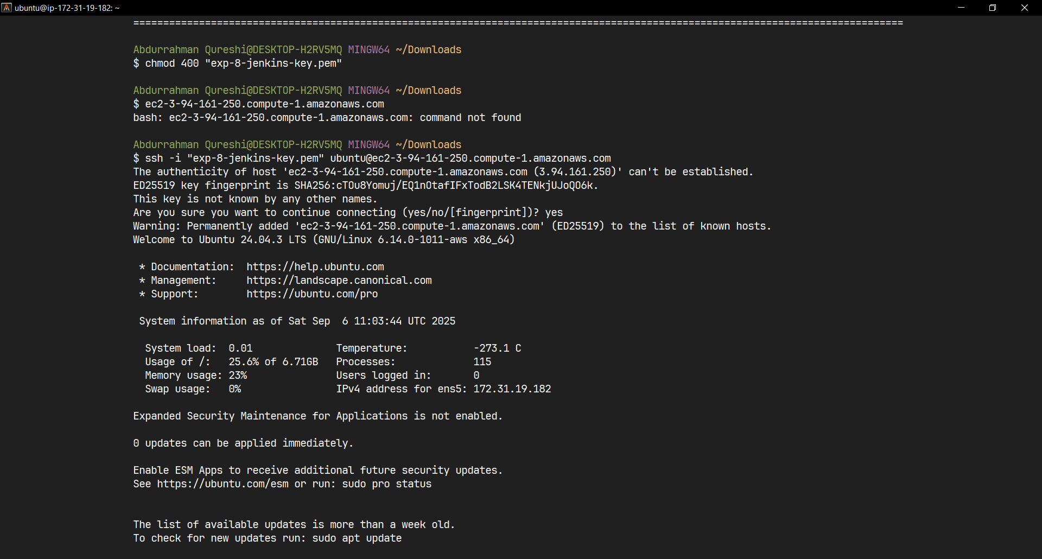

Connecting to the Instance on Alacritty(Terminal)

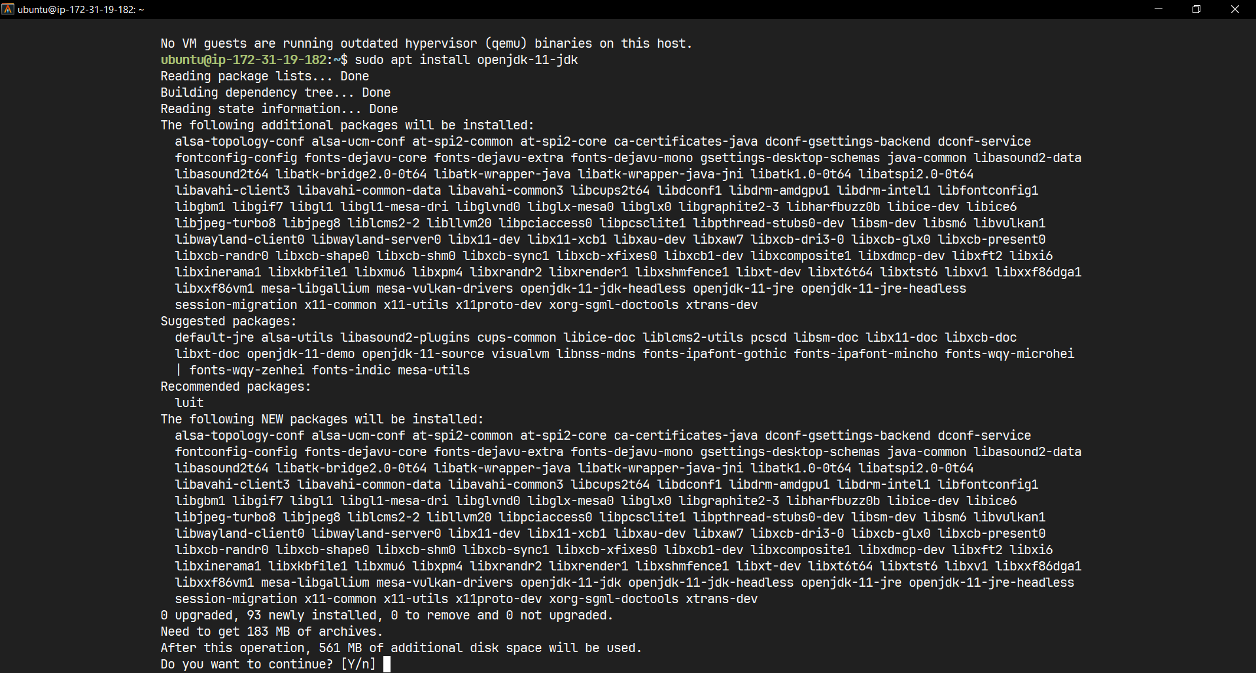

Updating system

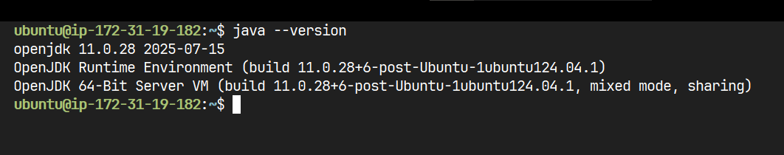

Checking java version

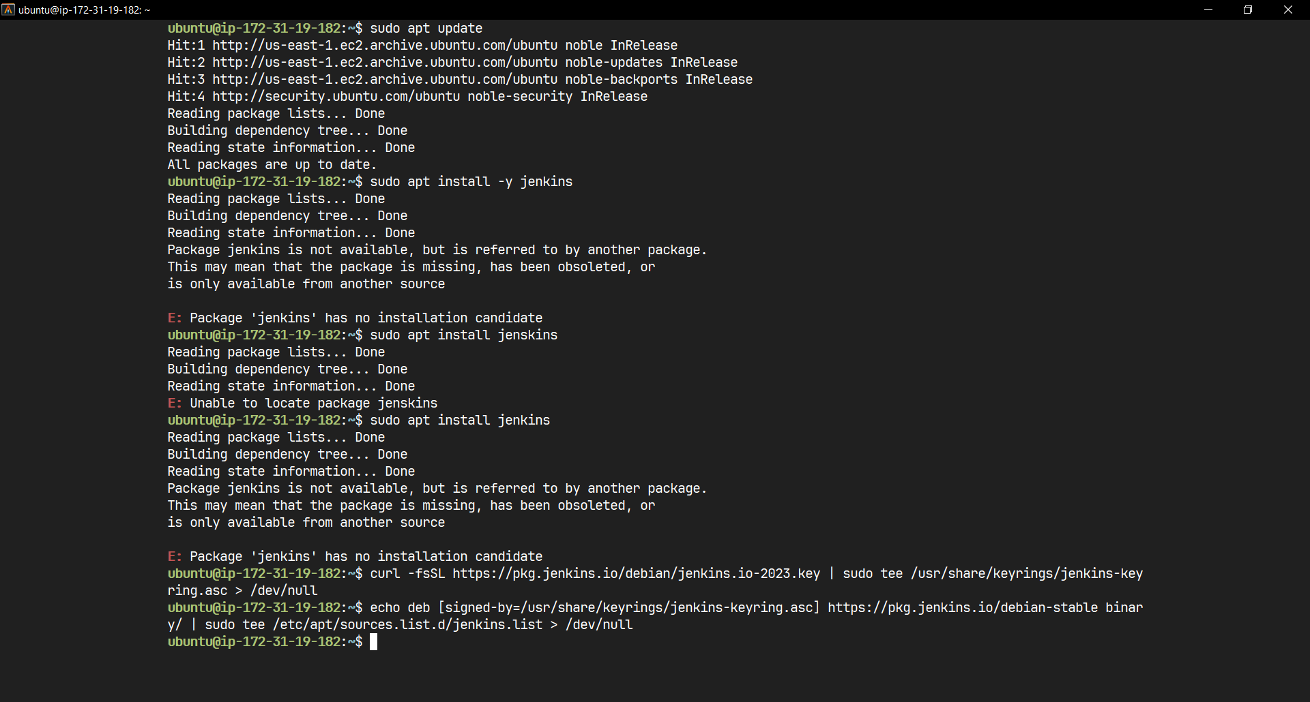

Installing Jenkins

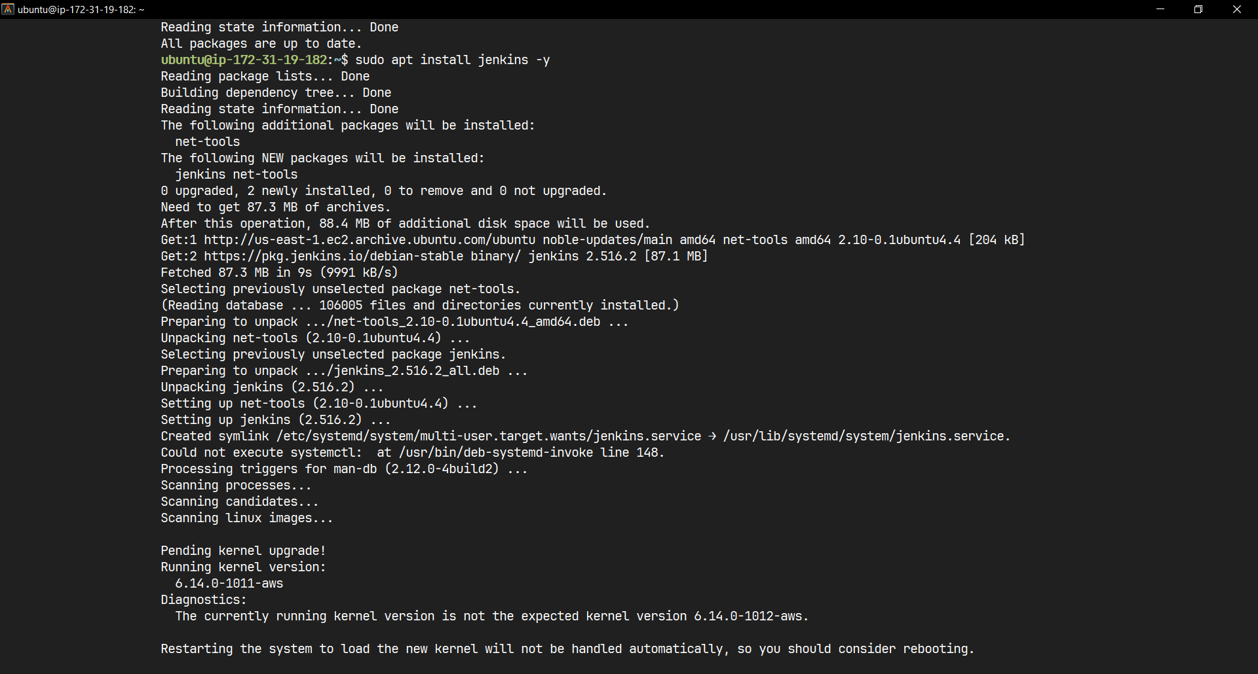

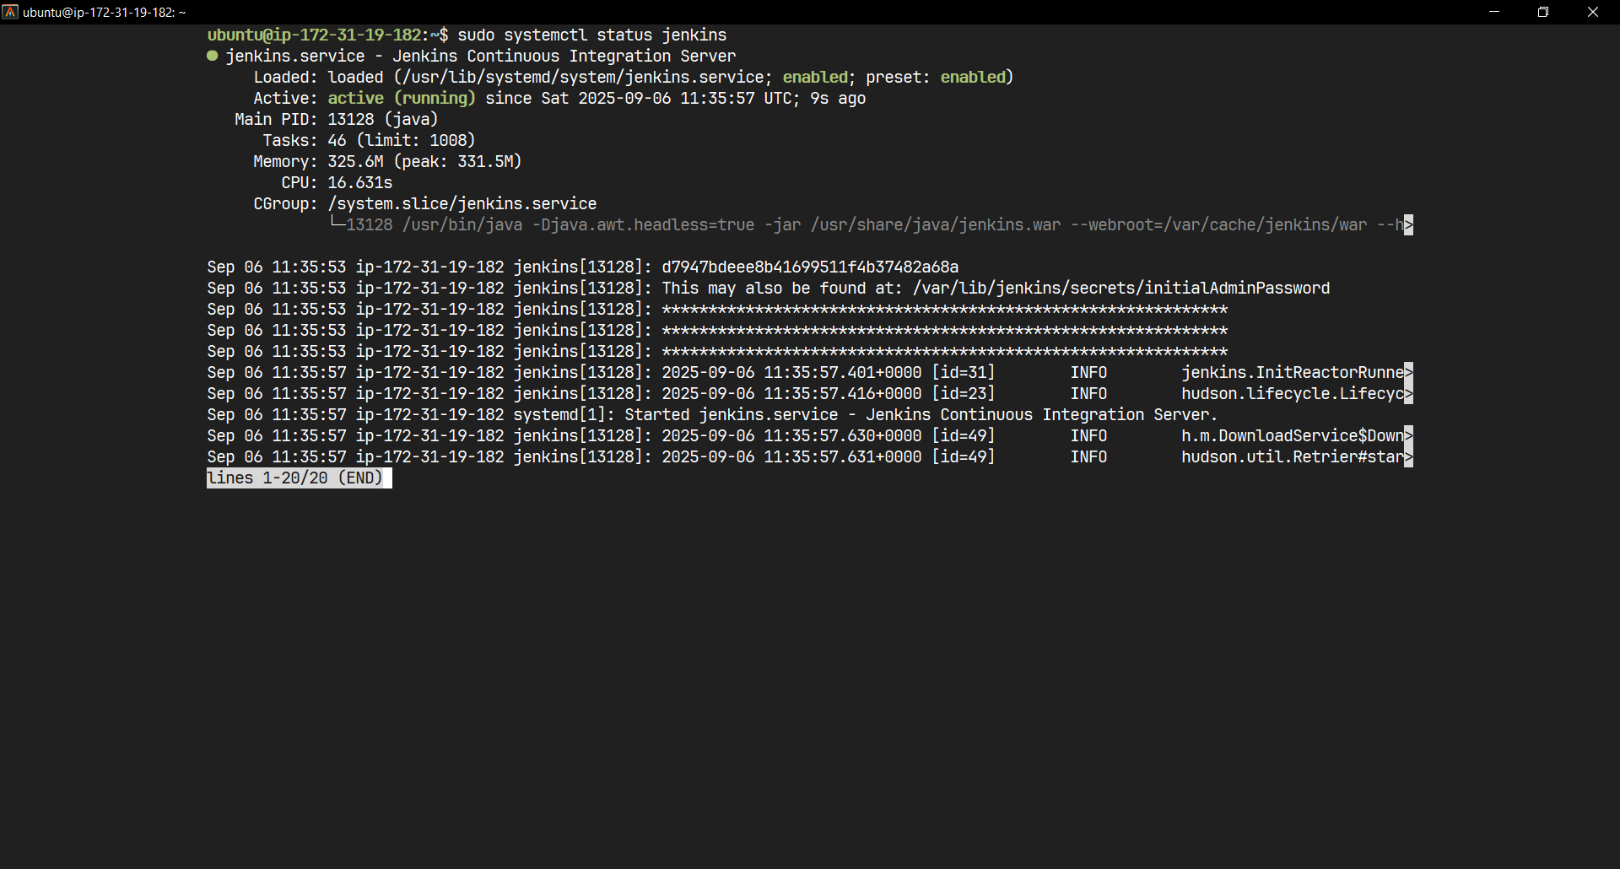

Starting Jenkins Server

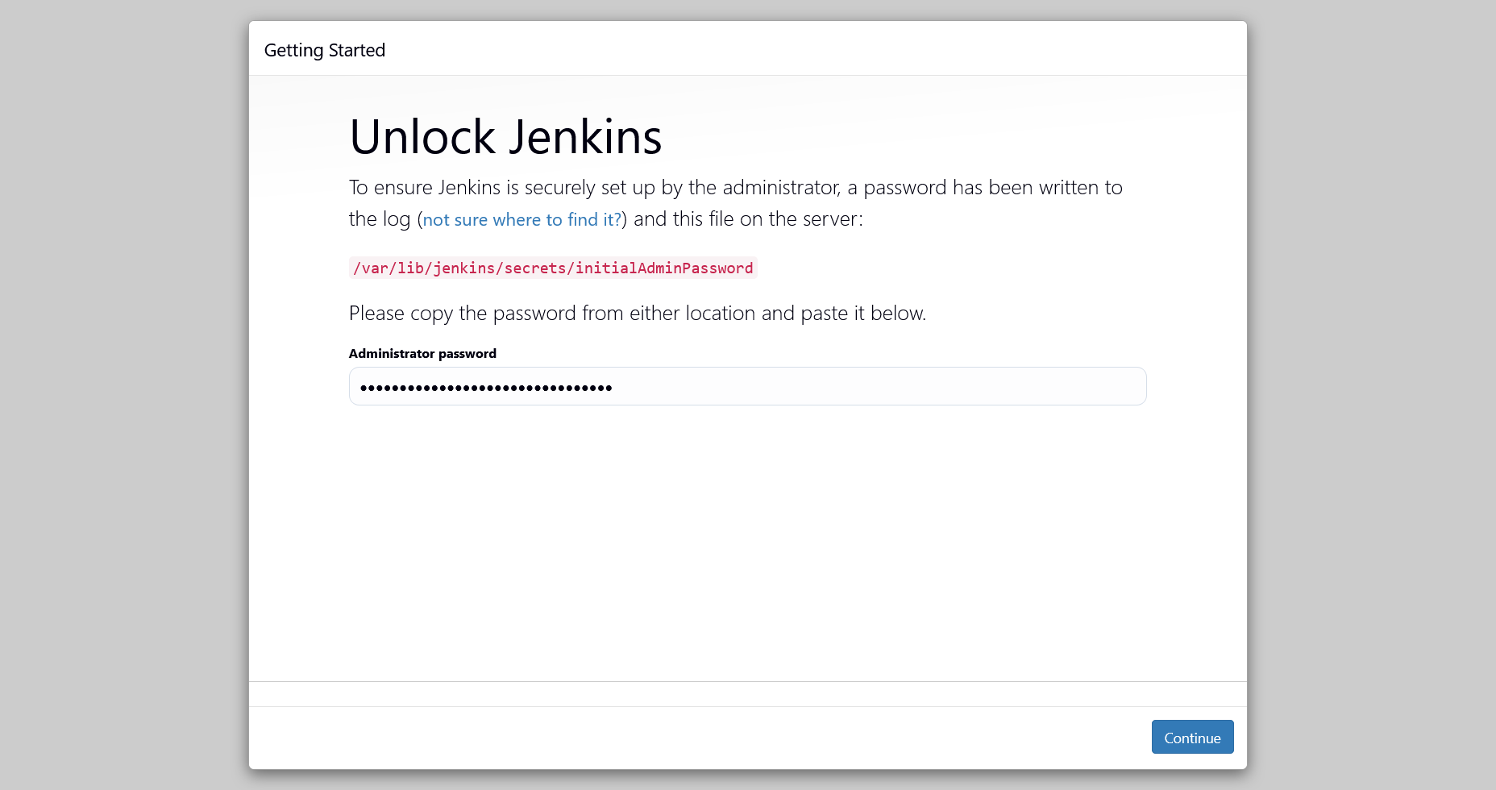

Opened on http://3.94.161.250:8080

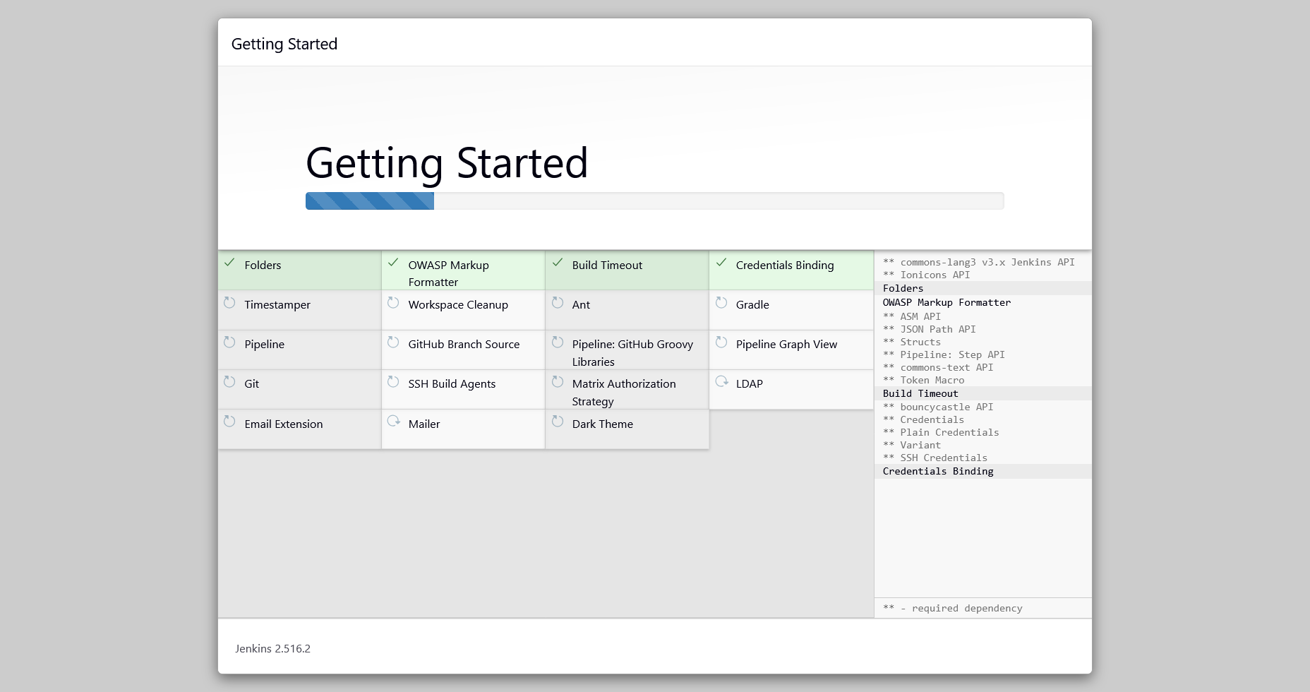

Installing Plugins

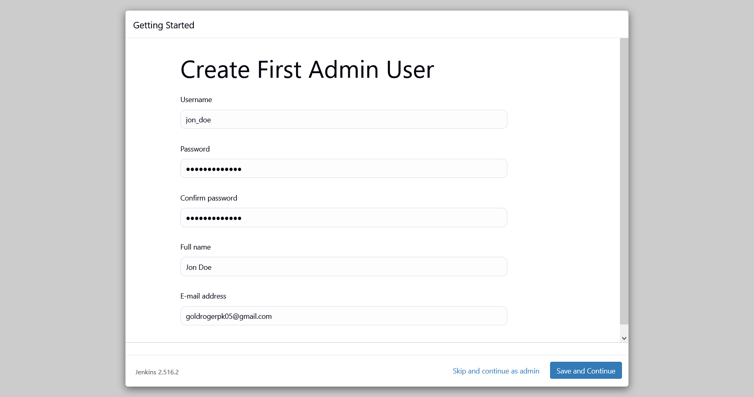

Creating Admin

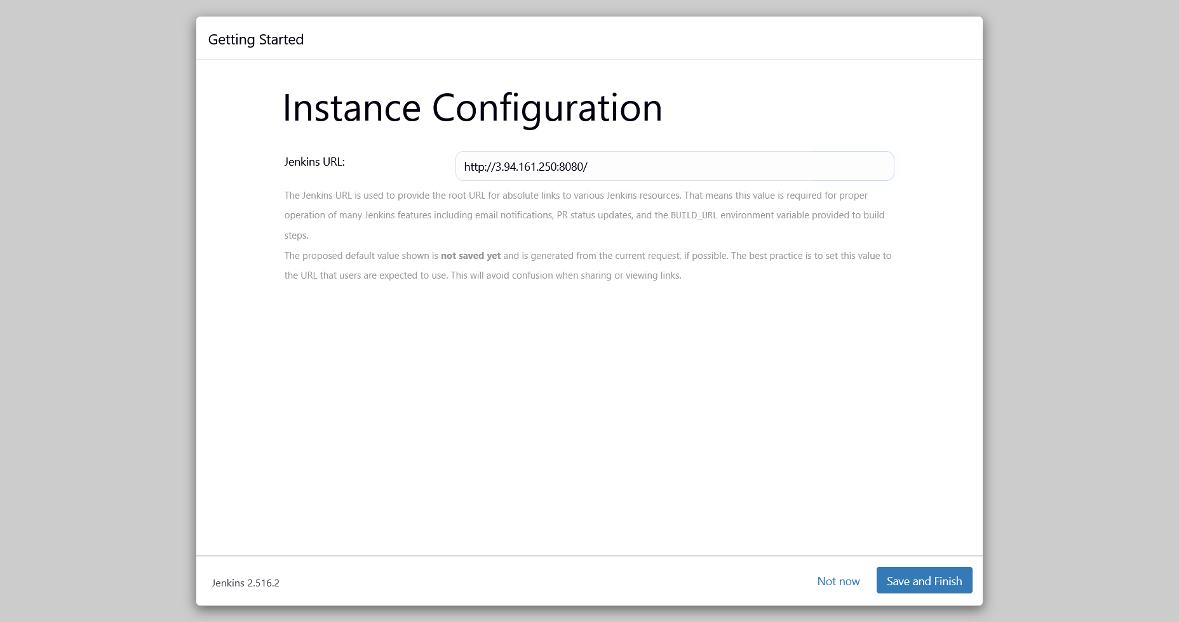

Connecting Instance

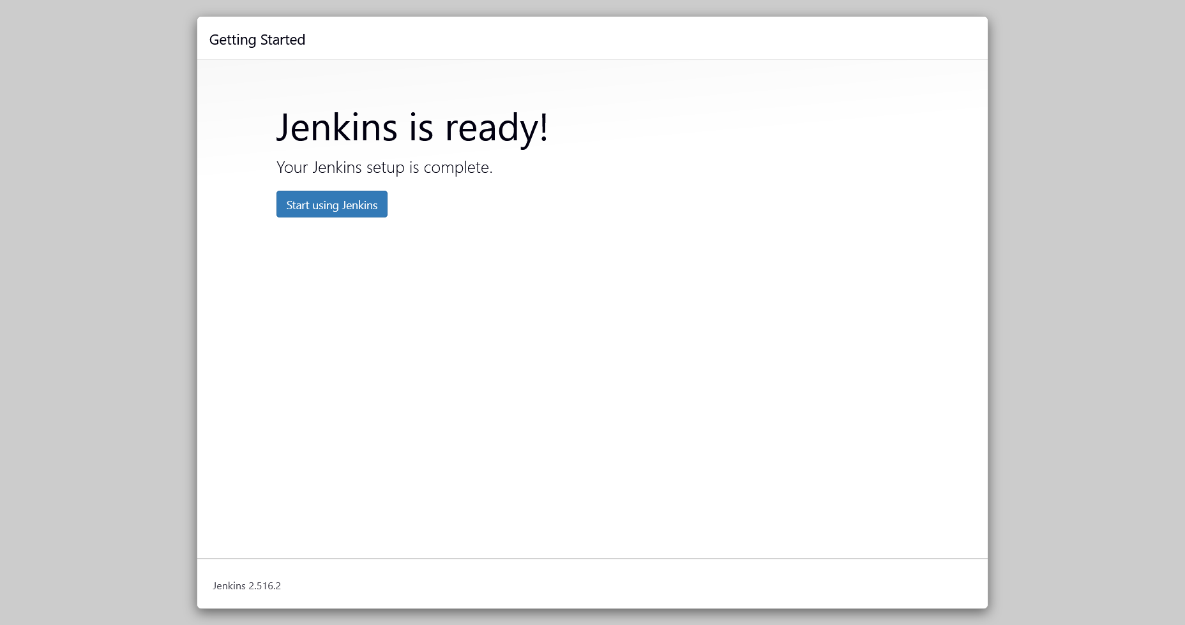

Setup Completion

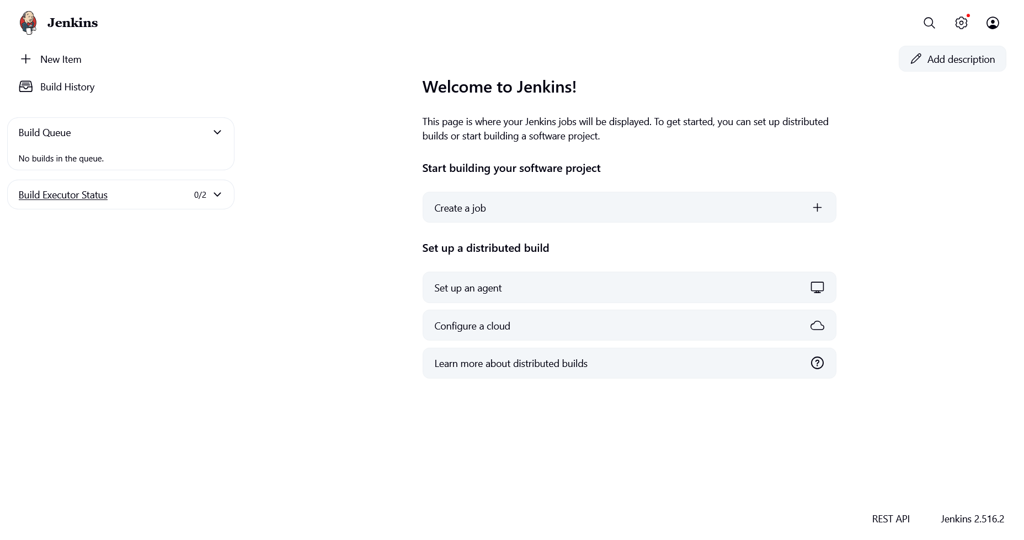

Jenkins Home Page

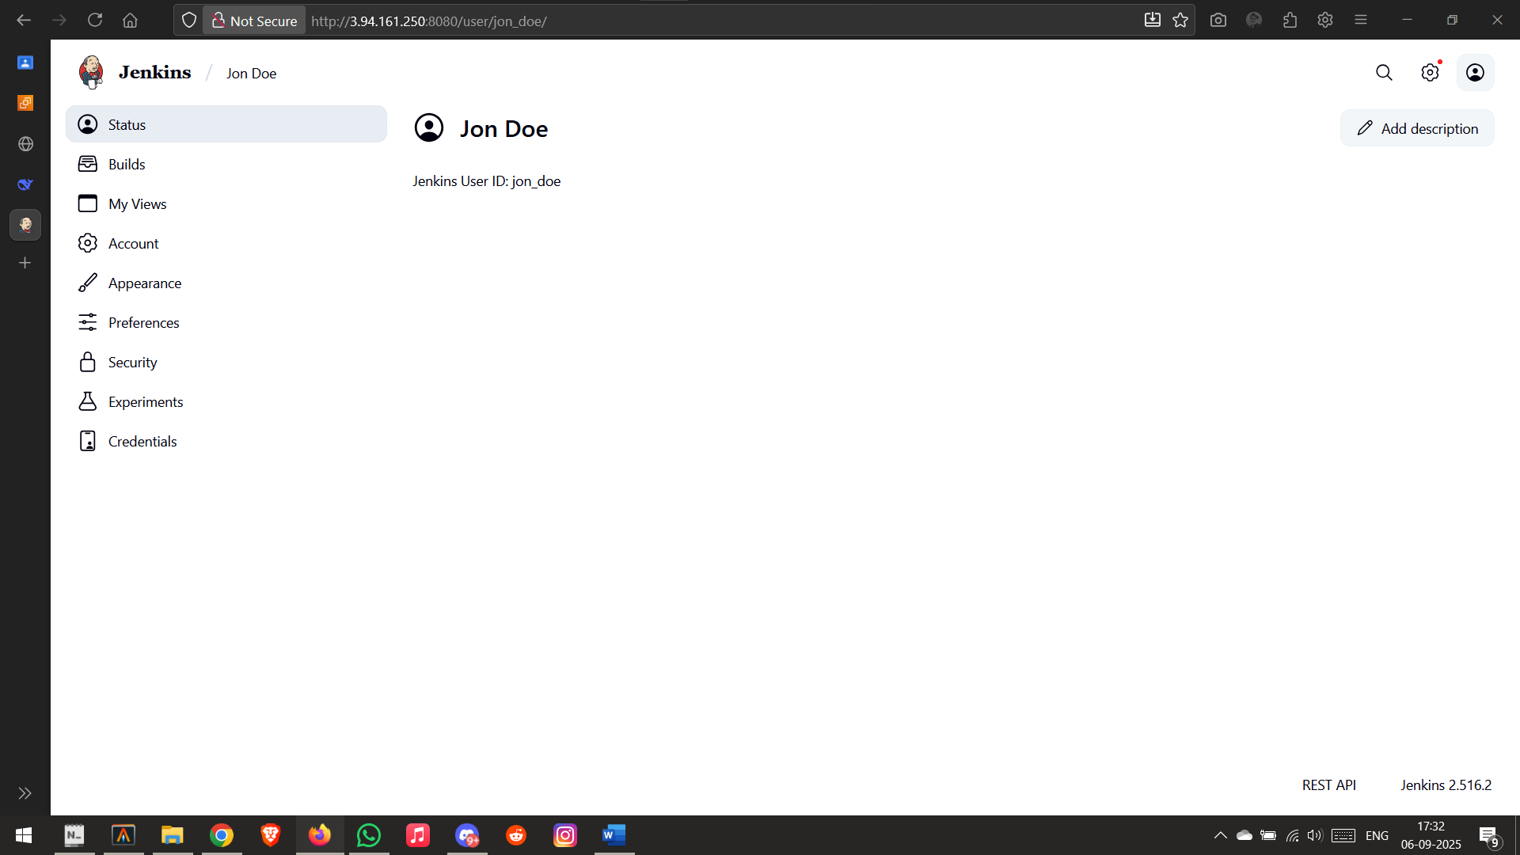

Jenkins User Page

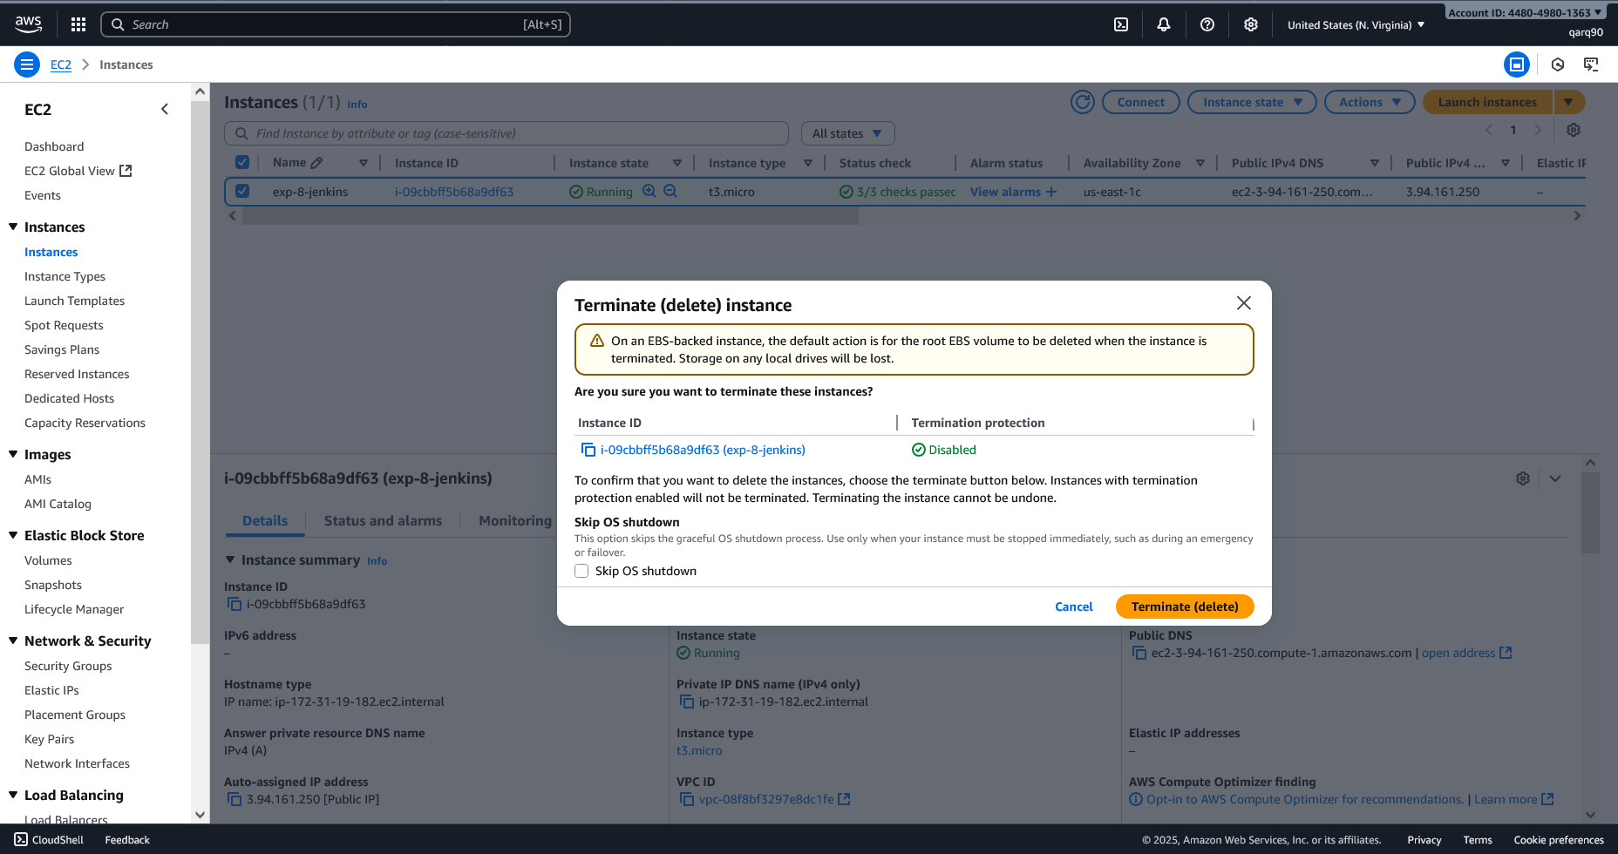

Deleting Instance

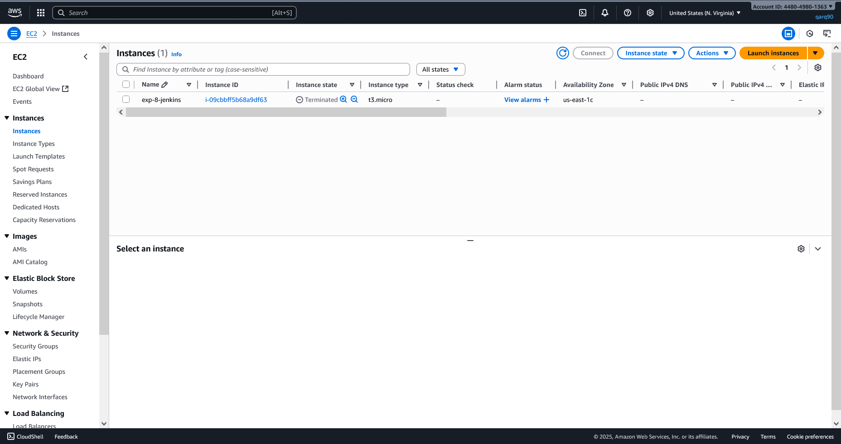

Instance Terminated Successfully

sudo nano /etc/default/Jenkins

JAVA_HOME=/usr/lib/jvm/java-17-openjdk-amd64

sudo journalctl -u jenkins.service -b --no-pager | tail -20

sudo ln -sf /usr/lib/jvm/java-17-openjdk-amd64 /usr/lib/jvm/default-java

sudo systemctl daemon-reload

sudo systemctl start jenkins